Proxy voting form

If you are unable to attend the Annual General Meeting of the charity on Tuesday 25th June 2024 and wish for somebody else to vote on your behalf, please submit this proxy form to be received by the charity by 5.00pm on Monday 24th June 2024, by either of the following methods:

PREFERABLY BY EMAIL: Attaching a scanned copy of the form to enquiries@wkwt.org.uk for the attention of Ed Green.

OTHERWISE BY POST: For the attention of Ed Green at Warwickshire Wildlife Trust, Brandon Marsh Nature Centre, Brandon Lane, Coventry CV3 3GW

I, (your name) _______________________________________

of (address) ___________________________________________________________________

member of Warwickshire Wildlife Trust (membership number) _________________________

hereby appoint the chair of the meeting / (name of proxy) _____________________________
[Please select and complete as appropriate]

to vote for and on my behalf at the Annual General Meeting of the charity to be held on 25th June 2024 and at every adjournment thereof.

This form is to be used in respect of the resolutions mentioned below as follows:

RESOLUTIONS | For | Against
- To approve the minutes of the AGM held on 20th June 2023.
- To adopt the Annual Report, Statement of Accounts and Auditors' Certificate for 2023.
- Election of the following co-opted Trustees to serve for 2024-2026:
Darren Male, Neil Rawlinson, Mark Wright
- Election of new Trustees to serve for 2024-2026:
Jacqui Staunton, Kevin Moffatt, Julie Reynolds
- To adopt the amended Articles of Association of Warwickshire Wildlife Trust Ltd
- To elect Auditors for 2024: Saffrey LLP

Unless otherwise instructed, the proxy may vote as they think fit or abstain from voting.

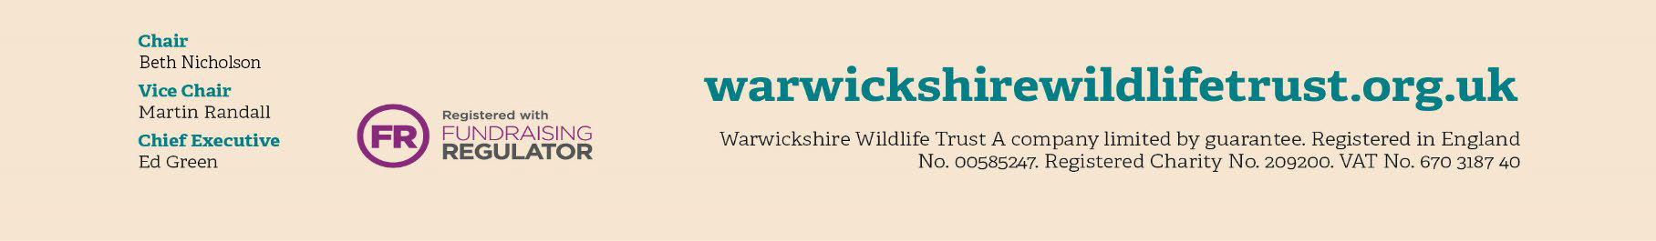
Signed: __________________________________Dated: __________________________

